


Vestibular nervous system

What is the vestibular system anyways?

The vestibular is a system that contains parts of the inner ear and nervous system. It controls equilibrium, balance and orientation.

Audiology Now INC.

144 Naples Ave
Warwick, RI 02886

Phone | 401.335.8000
Fax | 401.423.7558

www.Audiology-now.org

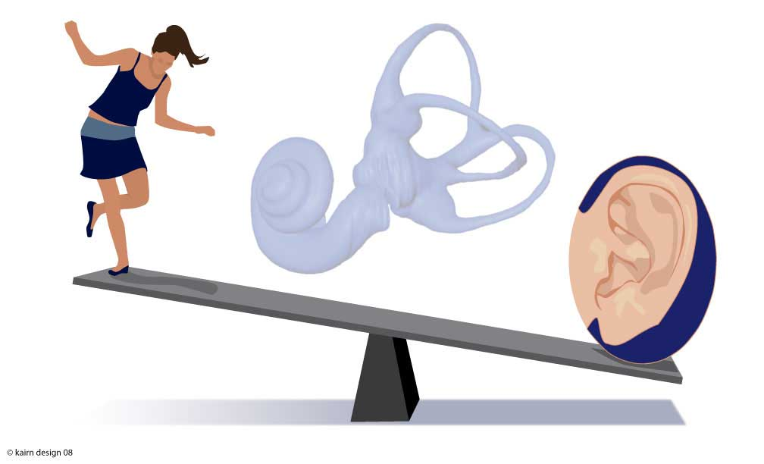

Delete text and place photo here.
Enter Contact Information Here | 1127 Lombard Blvd. San Francisco, CA 59802 | phone 555.555.5555 | fax 555.555.5555
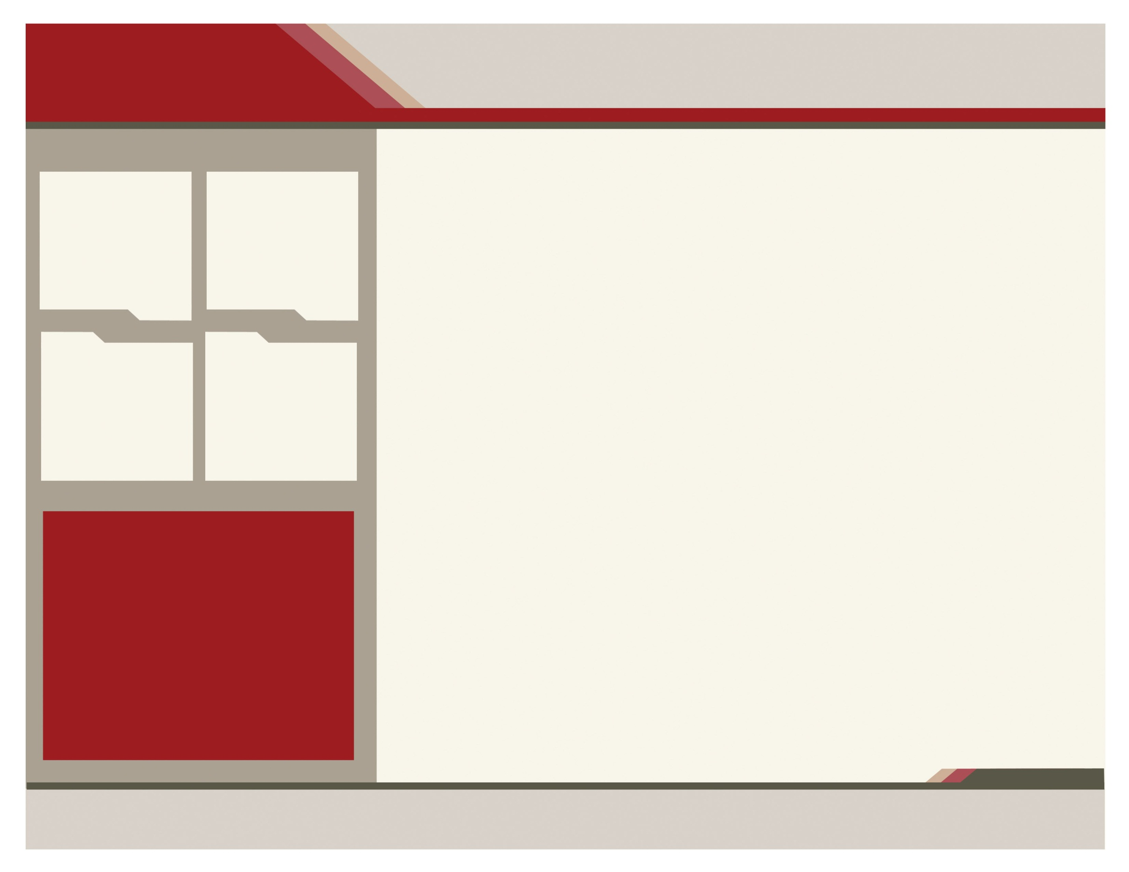
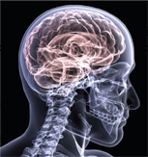

we DO
Videonystagmography Tests!!
“BalanCE IS LIKE A BOX OF CRYSTALS”

DO YOU SUFFER FROM DIZZINESS WHEN YOU:

- Bend down quickly?
- Perform any kind of eye movement?
- Lie down on your side?
- Position your head a certain way?

CALL and BOOK your free consultation TODAY!!
Videonystagmography Testing:
VNG testing is used to determine whether or not dizziness may be due to inner ear disease. It measures involuntary eye movement (nystagmus) using goggles containing a video system, which measures the balance system when stimulated in various ways. The test is broken down into four parts:
- Oculomotor Testing: evaluates the movement of the eyes as they follow a target.

- Positional Test: measures dizziness involved in various positions of the head and body.

- Caloric Test: positioning the body in a 45 degree angle while stimulating the inner ear with warm and cool air to determine the function.
The vestibular system is housed in the inner ear. The cochlea, the inner ear's organ of hearing, is connected to three other bony structures called the semicircular canals, which extend from a central chamber called the vestibule. The semicircular canals consist of membranous tubes inside of bony exterior tubes. The utricle and saccule are housed in the vestibule (they detect linear acceleration & together, are known as the "otolithic organs.") The vestibule and the semicircular canals are filled with fluid. Similar to the cochlea for hearing, the movement of this fluid triggers nerve impulses that send information to the brain. The semicircular canals aid the balance system in perceiving motion.
Where is it?

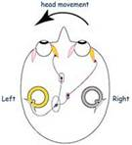

.

Labyrinth of the middle ear

www.Audiology-now.com
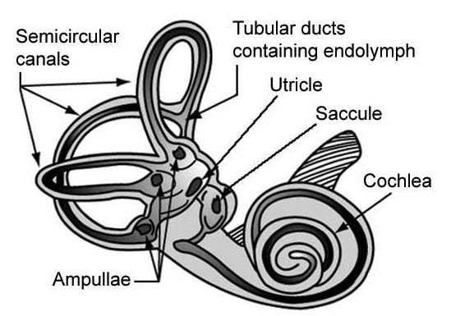

HOW DOES IT WORK?
*helps to send proprioceptive feedback to the brain (awareness of one's own body location & movements in space, and contributes to the body's sense of balance)
*Vestibular system structures perceive two types of movement:
1. Angular acceleration: rotational movement
2. Linear acceleration: motion along a straight line, both up and down & side to side.

caption
Vestibular system

